Germany and Italy
Cultural exchange at the heart of Europe
A workshop
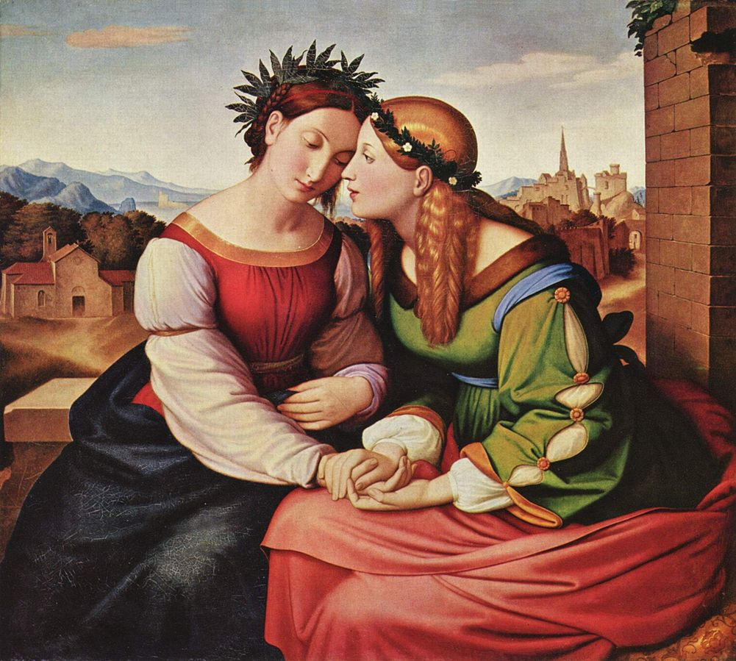
Friedrich Overbeck: Italia und Germania
Luca Renzi
Italianity / Italianness / Italianism / Italism
(Special guest Luca Renzi is Associate Professor of German, University of Urbino)
Paolo Bartoloni
The Italian Renaissance as a global phenomenon: A German Construct?
Michael Shields
Harps, Prostitution and Opera Buffa. Heinrich Heine’s wilfully German view of Italy (Die Reise von München nach Genua, 1830)
Hans-Walter Schmidt-Hannisa
Nazarener and Deutschrömer. German painters in Italy in the first half of the
19th century
Date: Thursday, 5 October 2017, 5-7 p.m.
Venue: THB-G010 Moore Institute Seminar Room
All are welcome!

Organised by the Disciplines of German and Italian
School of Languages, Literatures and Cultures, NUI Galway

